DPU-BSTU Joint Institute

COURSE PROJECT
EXPLANATORY NOTE
Course name: Scripting Programming Languages
Topic: Development of a Web Application for a Music Store
Student 2nd year
Group 252 ________________ Luo Ximing
signature
Supervisor
Assistant ________________ Veronica Aleshauskas
position, academic degree, academic title signature

Grade received:
Supervisor _________________ ______________ Veronica Aleshauskas
signature date name and surname

Dalian 2026
Contents
Introduction 4
1.Design of the Web Application 5
1.1 Similar Solutions 5
1.2 Problem Statement 8
2.Development of the Web Application 9
2.1 Website Structure 9

Introduction
A modern dental clinic website is not only an information resource. It is an important communication platform between a clinic and its patients. A well-designed website should allow visitors to obtain information about dental services, learn about specialists, find the clinic location and contact information, and submit an appointment request.
The development of such a website requires attention to both visual design and functionality. The interface should be clear and intuitive so that users can quickly find the required information. At the same time, the website should provide interactive elements that improve the user experience.
Another important requirement is responsive design. Users may access a medical website from desktop computers, tablets, and mobile phones. Therefore, the interface must adapt to different screen sizes while maintaining readable text, convenient navigation, and correctly displayed content.
The project uses HTML5 to create the structure of the web pages, CSS3 to define the visual appearance and responsive layout, JavaScript to implement interactive functionality, and SVG for scalable graphic elements.
The project goal is to develop a modern, responsive, and user-friendly website for Luo Dental Clinic.
The main objectives of the coursework are:
- Analyze existing websites in the dental and medical services sector.
- Identify their main advantages and disadvantages.
- Develop the structure and visual layout of the website.
- Implement the website using HTML5 and CSS3.
- Add interactive functionality using JavaScript.
- Implement responsive behaviour for mobile and desktop devices.
- Provide information about dental services, doctors, locations, and contacts.
- Implement appointment and contact forms.
- Test the website on different screen sizes and browsers.
- Prepare a user manual and technical documentation.
This structure allows for a systematic presentation of the entire development lifecycle: from initial analysis and design through implementation, testing, and final evaluation. The following sections will provide a detailed account of each stage, with particular emphasis on the JavaScript implementation, which constitutes the core of the application's interactive functionality.

1.Design of the Web Application
Before developing the website, existing dental clinic websites were analyzed. The purpose of this analysis was to identify common design patterns, useful functions, and problems that should be avoided in the developed application.
The analysis focused on the following aspects: navigation structure; presentation of dental services; presentation of doctors and specialists; contact information; appointment functionality; responsive design; visual hierarchy; interactive elements.

1.1 Similar Solutions
Several existing dental clinic websites were considered during the design stage. The first example is the Yahe Dental Clinic website (http://www.yahekq.com/).
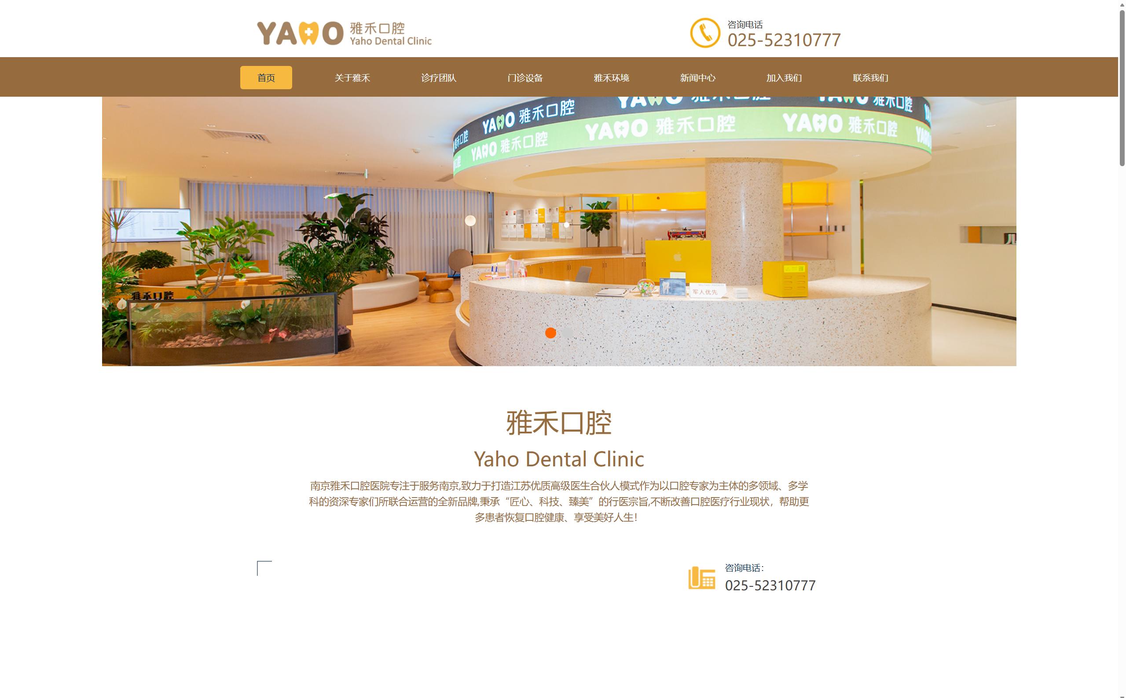
Figure 1.1 – Home page of the “Yahe Dental Clinic” website
One of its main advantages is clear positioning as a dental clinic with an experienced specialist team. Information about doctors and their qualifications helps establish trust with potential patients. The website also provides contact information and location information, which makes important practical information accessible.
However, the website has several disadvantages. The layout is relatively simple and contains large blocks of text. This reduces visual hierarchy and may make the information more difficult to scan. The website also lacks an online appointment function and an interactive service-selection interface. In addition, the mobile experience can be improved.
The second example is iKang Dental(https://www.ikangdental.com/).
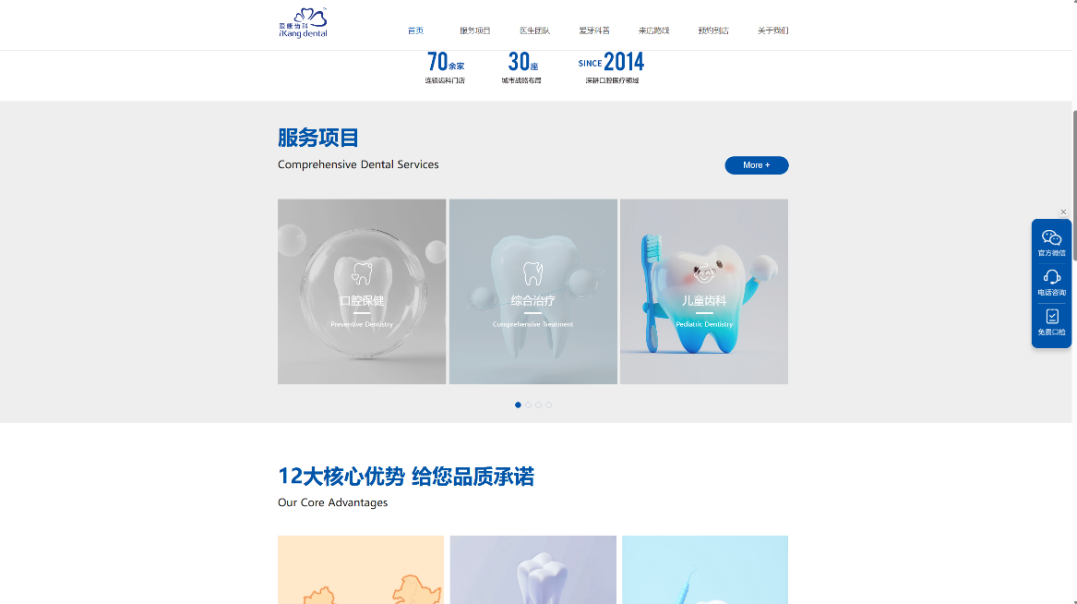
Figure 1.2 – the structured presentation of dental services of the “iKang” website
A major advantage of this website is the structured presentation of dental services. Services are divided into categories such as preventive dentistry, implant dentistry, and orthodontics. This structure makes it easier for users to locate a required treatment.
The website also emphasizes professional qualifications, safety, and patient care. These elements help improve the credibility of the clinic.
The main disadvantage is the large amount of information displayed on the homepage. Numerous icons and text blocks can make the interface visually dense. A large navigation menu may also make it more difficult for users to immediately locate doctor information or appointment functions.
The third example is the website of the Stomatological Hospital of Southern Medical University (https://www.smukqyy.cn/home).
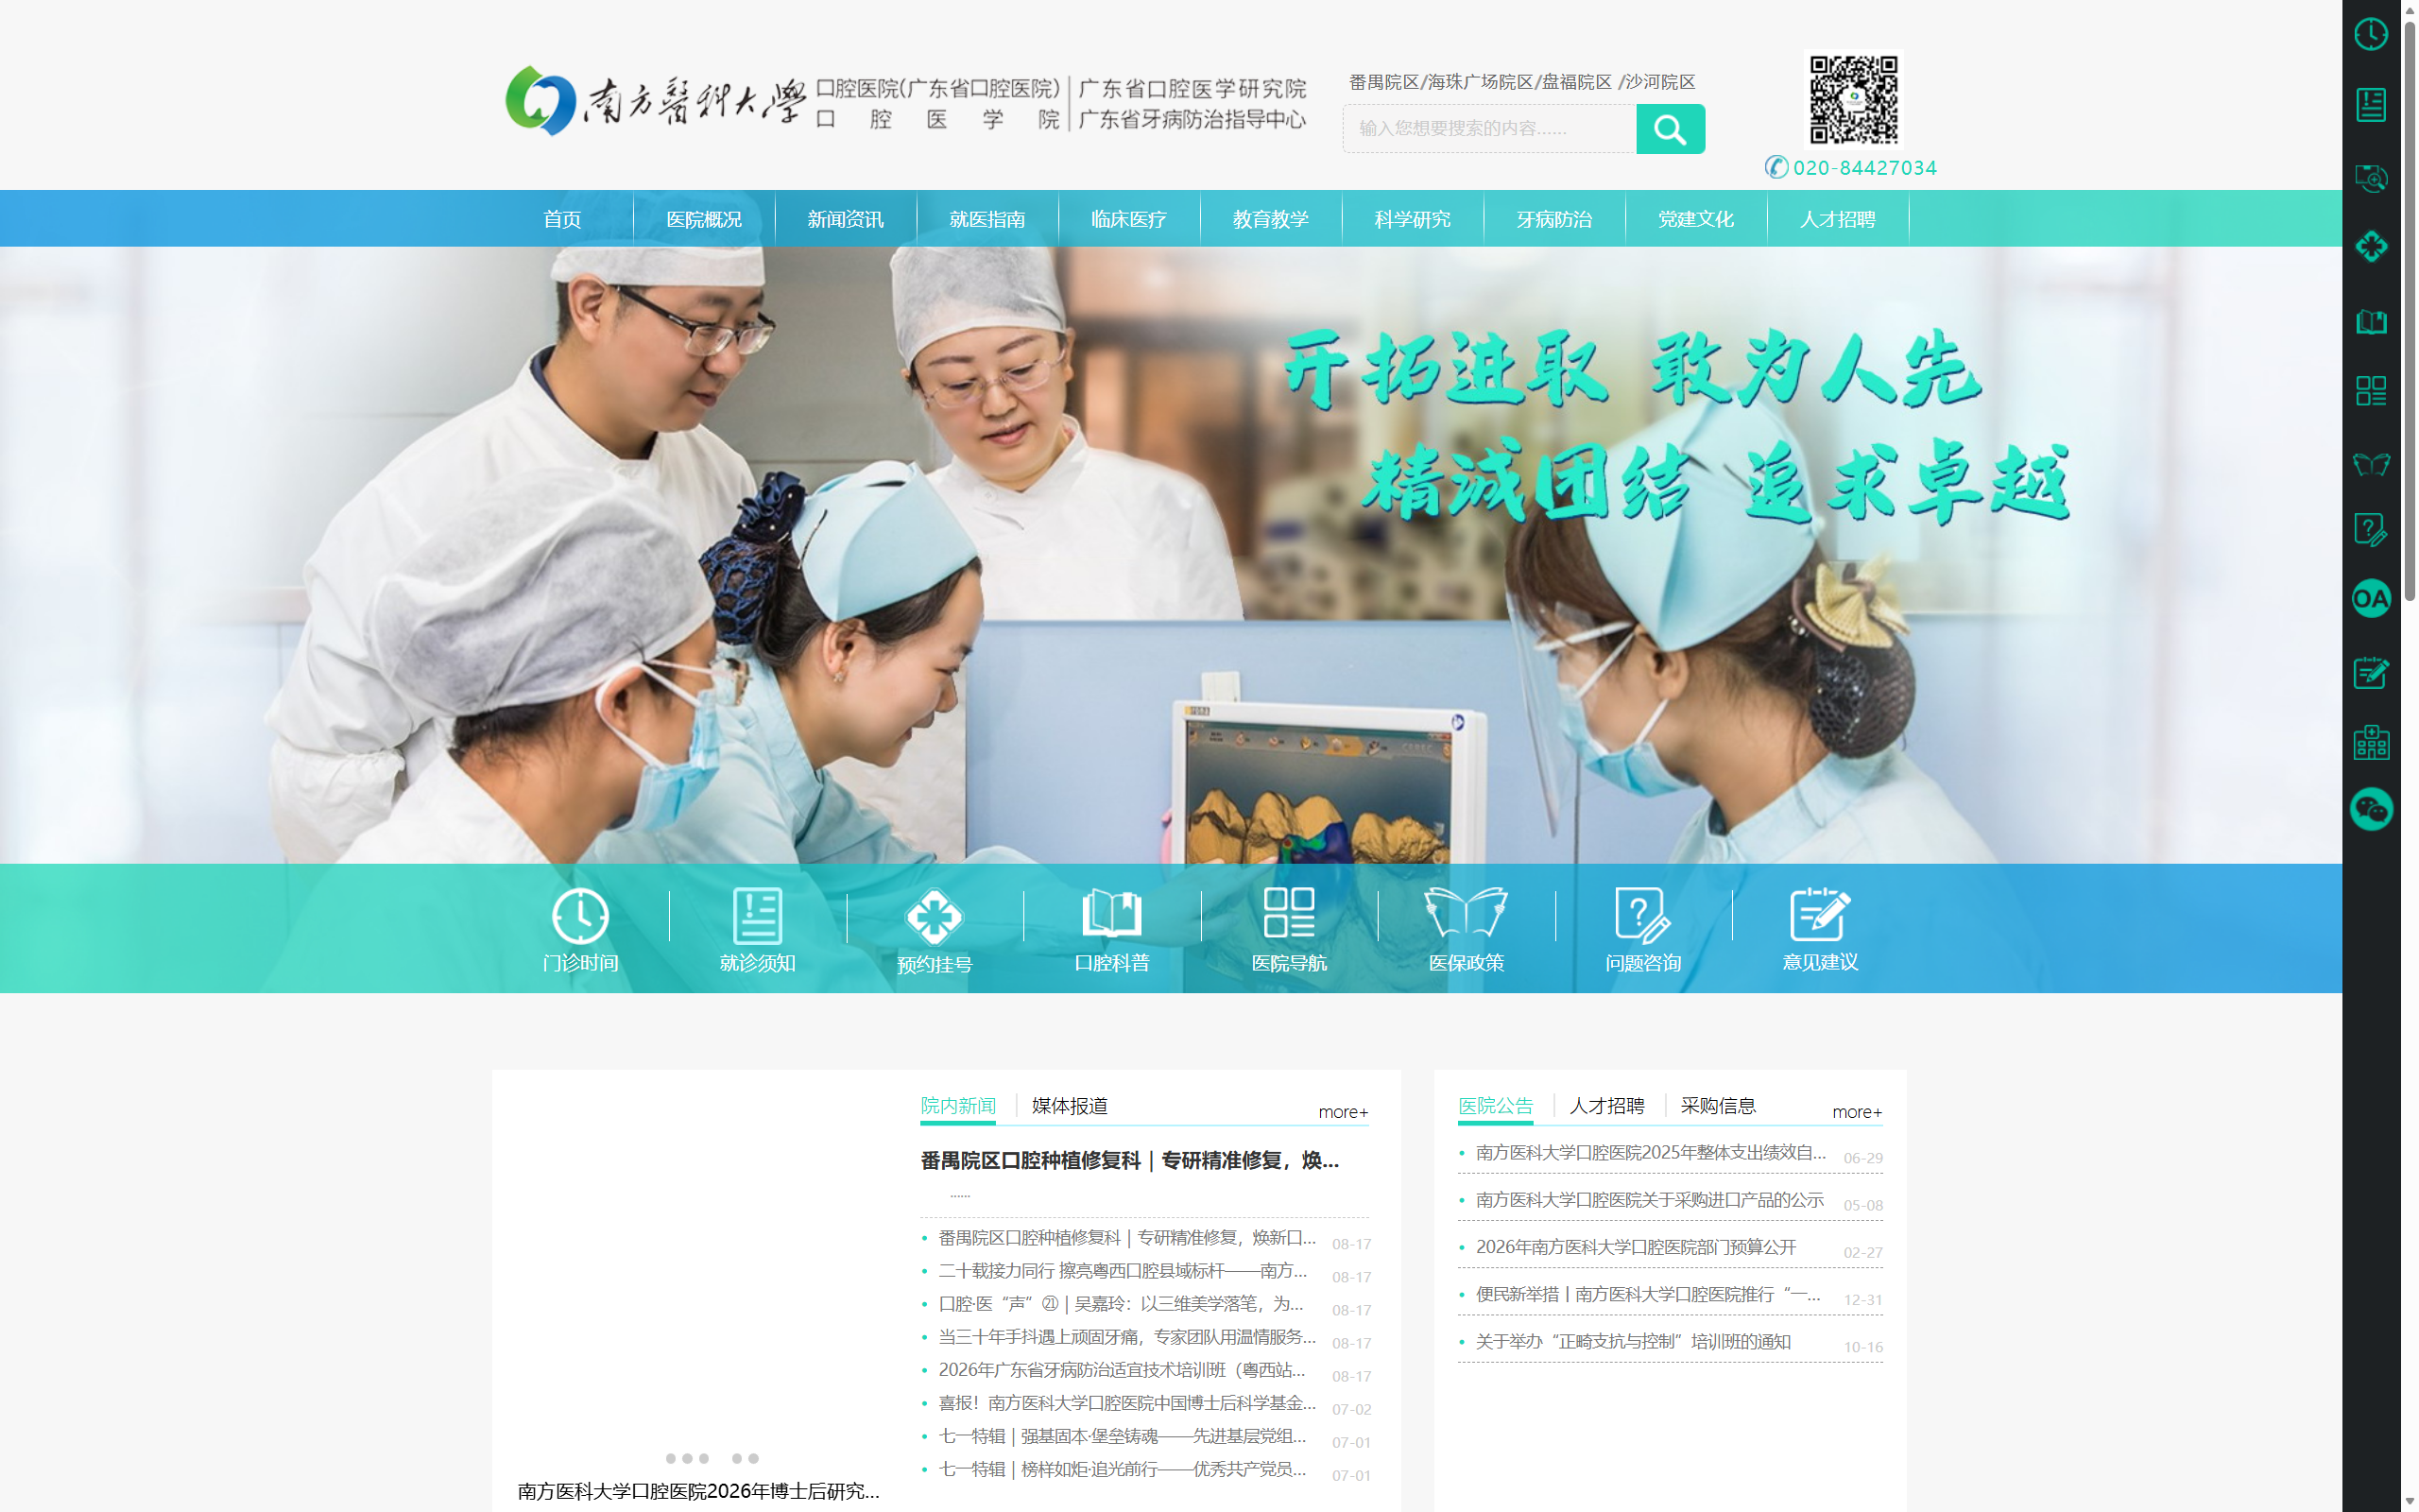
Figure 1.3 – Home page of the “Stomatological Hospital of Southern Medical University” website
The website provides authoritative institutional information, academic news, and information about hospital locations. It also contains contact and supervision information.
However, the interface is relatively text-heavy and focuses strongly on institutional and academic information. Patient-oriented functions are less prominent. Treatment information, doctor profiles, and appointment functionality are not presented as clearly as they could be. The visual design also contains fewer modern interactive elements.
The analysis identified several common problems:
- Excessive amounts of information are sometimes displayed at the same time.
- Patient-oriented functions are not always easy to find.
- Appointment functions may be absent or insufficiently visible.
- Service categories may not provide convenient interaction.
- Some websites have limited mobile optimization.
- Dense navigation can make information difficult to locate.
These observations were used to define the requirements for the developed website. The original analysis of these three websites also identified patient experience, information accessibility, interactivity, and responsive design as important areas for improvement.

1.2 Problem Statement
The developed web application is a multi-page website for Luo Dental Clinic.
The website should provide users with the following main functions: obtain general information about the clinic; view available dental services; view doctor profiles; filter doctors by specialization; view clinic location and working hours; view contact information; send a message to the clinic; submit an appointment request; navigate the website using desktop or mobile devices.
The website will use the following main pages: Home, About Us, Gallery, Services, Doctors, Locations, Contacts,
Appointment
A consistent header and footer will be used throughout the website.
The header will contain the clinic logo, clinic name, and navigation menu. On smaller screens, the desktop navigation will be replaced by a hamburger menu.
The Home page will provide an introduction to the clinic, a hero section, information about the clinic, a photo gallery, a service preview, a doctor preview, and a quick appointment form.
The Services page will contain dental treatment categories. The following categories will be implemented:Preventive Dentistry; Restorative Dentistry; Orthodontics; Cosmetic Dentistry.
JavaScript will be used to switch between service categories without reloading the page.
The Doctors page will display specialist cards containing a photograph, name, specialization, experience, and biography. JavaScript filtering will allow users to display:
All;
Implantology;
Orthodontics;
Pediatric Dentistry;
General Dentistry.
The Locations page will contain clinic address, working hours, telephone information, interior photographs, and an interactive map mode.
The Contacts page will contain telephone and email information, address information, social-media buttons, an administration contact form, and an emergency contact section.
The Appointment page will contain a booking form with: First Name; Last Name; Email; Phone Number; Preferred Date; Service Type; Preferred Time.
The form will perform client-side validation before displaying a confirmation message.
The application will use HTML5, CSS3, JavaScript, and SVG. JavaScript functionality will be implemented using basic JavaScript without a JavaScript framework. The course example also specifies the use of ECMAScript 9 (ES2018) concepts such as const, let, arrow functions, template literals, array methods, classList, and event listeners.

2.Development of the Web Application

2.1 Website Structure
The website is based on a multi-page structure.
The common navigation contains the following links:
- Home;
- About Us;
- Gallery;
- Services;
- Doctors;
- Locations;
- Contacts;
- Appointment.
The navigation is implemented as an HTML unordered list. This allows the menu structure to remain simple and semantic.
The header is fixed to the top of the browser window. This allows users to access the main navigation while scrolling through the page.
On mobile devices, the horizontal navigation is hidden and replaced with a hamburger button. Clicking the button opens the mobile navigation panel. Clicking a navigation link closes the mobile menu.
The Home page contains the following main sections:
- Hero section.
- About the clinic.
- Clinic statistics.
- Photo Gallery.
- Services preview.
- Doctors preview.
- Quick appointment form.
The common footer contains clinic contact information, working hours, social-media links, and copyright information.
The website structure follows the requirement of using a consistent header and footer throughout the application. The original project already defines these navigation elements and the mobile hamburger menu.

2.2 HTML Implementation
HTML5 is used to create the structure of the web application.
The basic HTML document contains the document type declaration, language definition, character encoding, viewport configuration, page title, and CSS connection.
The basic structure is:
<!DOCTYPE html>
<html lang="en">
<head>
<meta charset="UTF-8">
<meta name="viewport"
content="width=device-width, initial-scale=1.0">
<title>Home | Luo Dental Clinic</title>
<link rel="stylesheet" href="index.css">
</head>
The <!DOCTYPE html> declaration specifies that the document uses HTML5.
The lang attribute defines the document language.
The meta charset element specifies UTF-8 character encoding.
The viewport element allows the page to adapt to the width of the user's device.
The title element defines the browser tab title.
The external stylesheet is connected using the link element.
The current website already uses this HTML5 structure and an external index.css stylesheet.
Semantic HTML elements are used to divide the page into logical areas:
- header;
- nav;
- main;
- section;
- footer;
- button;
- form.
For example, the header contains the logo, clinic name, desktop navigation, and mobile navigation.
The main content is divided into independent sections. This makes the document easier to understand and allows CSS and JavaScript to target individual components.
Images are provided with alt attributes so that their purpose can be identified when the image cannot be displayed.
Forms use HTML input types such as:
<input type="text">
<input type="email">
<input type="tel">
<input type="date">
<select>
Required fields use the required attribute for basic browser validation.

2.3 CSS Implementation
CSS3 is used to define the visual appearance and layout of the website.
The general design uses a blue and purple colour scheme suitable for a medical website. The page background is light, while the header and footer use darker colours to provide visual contrast.
The header uses a gradient background and is fixed to the top of the viewport.
The main content is limited by a maximum width so that large desktop screens do not produce excessively long lines of text.
Cards are used for:
- gallery items;
- dental services;
- doctors;
- appointment forms.
Rounded corners and shadows are used to create visual separation between content blocks.
The current CSS already implements a fixed header, gradient colours, responsive layout, cards, forms, footer, and a floating return-to-top button.
The gallery uses CSS Grid:
.gallery-grid {
display: grid;
grid-template-columns:
repeat(auto-fill, minmax(240px, 1fr));
gap: 20px;
}
This allows the number of columns to adapt automatically to the available screen width.
The service and doctor sections use flexible layouts so that cards can move to the next line when the available width becomes smaller.
Interactive visual effects such as hover transformations and colour changes are also implemented using CSS transitions.

2.4 JavaScript Implementation
JavaScript provides the interactive functionality of the website.
The JavaScript code will be divided into logical functions and event handlers. Event listeners will be attached using addEventListener().
Mobile Navigation
The mobile navigation is controlled using a hamburger button.
When the button is clicked, JavaScript toggles the open class:
function toggleMenu() {
mobileMenu.classList.toggle('open');
}

burger.addEventListener('click', toggleMenu);
The classList.toggle() method allows the same button to open and close the menu.
The current implementation already uses this approach.
Smooth Navigation
Internal navigation links will use smooth scrolling.
JavaScript obtains the target section and calls:
targetElement.scrollIntoView({
behavior: 'smooth',
block: 'start'
});
This provides a smoother transition between sections on the Home page.
Return-to-Top Button
A floating button is displayed after the user scrolls down the page.
JavaScript checks the scroll position:
if (
document.body.scrollTop > 20 ||
document.documentElement.scrollTop > 20
) {
scrollBtn.style.display = "block";
}
When the button is clicked, the page smoothly returns to the top.
The current implementation already contains this functionality and uses an SVG arrow as the button graphic.
Service Category Switching
The Services page will use JavaScript to switch between service categories.
The user will click a category button and JavaScript will:
- identify the selected category;
- remove the active state from other categories;
- add the active state to the selected category;
- display the corresponding service information;
- hide the other categories.
The page will initially display Preventive Dentistry.
Doctor Filtering
The Doctors page will use a JavaScript array containing doctor information.
Each doctor will have properties such as:
{
name: "...",
specialization: "...",
experience: 0,
category: "..."
}
When a user selects a filter, JavaScript will filter the doctor data and update the displayed cards.
The available filters will be:
- All;
- Implantology;
- Orthodontics;
- Pediatric Dentistry;
- General Dentistry.
This follows the functionality defined in the original project specification.
Form Validation
The Appointment and Contacts forms will use JavaScript for client-side validation.
The validation process will:
- prevent the default form submission;
- obtain the entered values;
- remove previous error messages;
- validate required fields;
- validate the email address;
- validate the selected date;
- display appropriate error messages;
- display a successful confirmation message when all required fields are valid.
For example, an email validation pattern can be implemented using a regular expression.
The use of event listeners and client-side validation follows the interaction model demonstrated in the course example.
Appointment Confirmation
After successful validation, the Appointment page will display a confirmation message.
The website will not claim that a real appointment has been created on a medical booking server. Instead, the interface will demonstrate the submission process and inform the user that the clinic should contact the patient to confirm the appointment.
This keeps the implemented functionality consistent with a front-end coursework project.

2.5 Responsive Design
Responsive design is an important part of the application.
The website will support two main layout ranges:
- mobile devices up to 768px;
- desktop layouts from 769px and above.
On desktop screens:
- the horizontal navigation is displayed;
- content uses multi-column layouts;
- gallery cards are arranged in several columns;
- service and doctor cards are displayed side by side.
On mobile screens:
- the desktop navigation is hidden;
- the hamburger button is displayed;
- the mobile navigation panel becomes available;
- cards are arranged vertically or in fewer columns;
- text sizes are reduced where necessary;
- forms use the available screen width;
- images remain responsive.
The course example explicitly defines 768px as the mobile breakpoint and requires the page to adapt to device width.
The website will also be checked in major modern browsers to ensure that the layout and JavaScript functions operate consistently.

- Testing of the Web Application

Conclusion

Appendix A Web Application screenshots
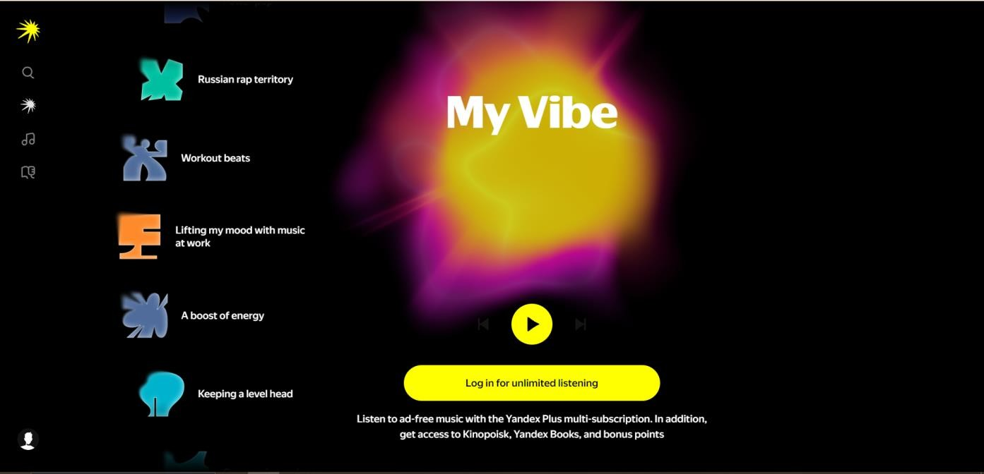
Figure A.1 – Home page
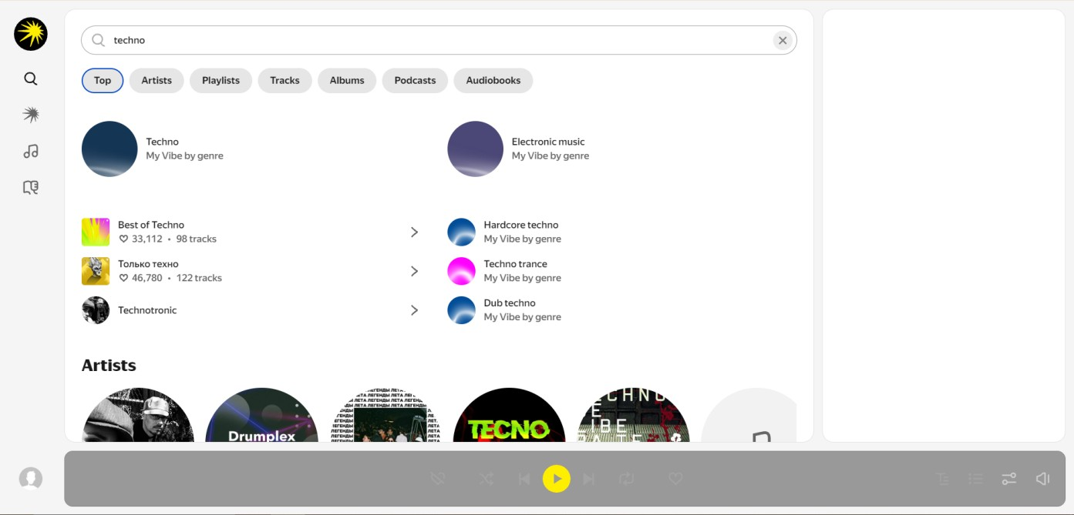
Figure A.2 – Search page
Appendix B Search functionality listing
const products = [
{ id: 1, artist: 'The Beatles', title: 'Abbey Road', genre: 'Rock', price: 12.99 },
{ id: 2, artist: 'Daft Punk', title: 'Random Access Memories', genre: 'Electronic', price: 14.99 },
// ... more products
];

const searchProducts = (query) => {
const trimmedQuery = query.trim().toLowerCase(); if (trimmedQuery === '') {
renderAllProducts(); // show all products if search is empty return;
}
const results = products.filter(product =>
product.artist.toLowerCase().includes(trimmedQuery) || product.title.toLowerCase().includes(trimmedQuery) || product.genre.toLowerCase().includes(trimmedQuery)
);
renderResults(results);
};

document.querySelector('#search-button').addEventListener('click', ()
=> {
const query = document.querySelector('#search-input').value; searchProducts(query);
});

document.querySelector('#search-input').addEventListener('keyup',
(event) => {
if (event.key === 'Enter') {
const query = document.querySelector('#search-input').value; searchProducts(query);
}
});
Appendix C
Data verification listing
document.addEventListener('DOMContentLoaded', () => {
// Set default values
document.querySelector('#genre').value = 'all'; document.querySelector('#newsletter').checked = true;

const form = document.querySelector('#registration-form'); form.addEventListener('submit', (event) => { event.preventDefault();

// Clear previous errors
document.querySelectorAll('.error-message').forEach(el => el.textContent = ''); document.querySelectorAll('.form-input').forEach(el => el.classList.remove('error'));

let isValid = true;

const name = document.querySelector('#name').value.trim(); if (name.length < 2) { document.querySelector('#name-error').textContent = 'Full name must be at least 2 characters.';
document.querySelector('#name').classList.add('error'); isValid = false;
}

const email = document.querySelector('#email').value.trim(); const emailPattern = /^[^\s@]+@[^\s@]+\.[^\s@]+$/; if (!emailPattern.test(email)) {
document.querySelector('#email-error').textContent =
'Please enter a valid email address.';
document.querySelector('#email').classList.add('error'); isValid = false;
}

const password = document.querySelector('#password').value; if (password.length < 6) {
document.querySelector('#password-error').textContent =
'Password must be at least 6 characters.';

document.querySelector('#password').classList.add('error'); isValid = false;
}

const confirm = document.querySelector('#confirmpassword').value;
if (password !== confirm) {
document.querySelector('#confirm-error').textContent = 'Passwords do not match.';

document.querySelector('#confirmpassword').classList.add('error'); isValid = false;
}

if (isValid) { const userData = { name: name, email: email,
genre: document.querySelector('#genre').value, newsletter:
document.querySelector('#newsletter').checked
};
console.log('Registration successful:', userData); document.querySelector('#form-message').innerHTML = '<p class="success"> Registration successful! Welcome to the music store!</p>';
}
});
});

